FOR RELEASE THURSDAY, NOVEMBER 2ND, 2023, AT 11AM EDT

New Video: Molchat Doma Performs in the Moog Sound Lab with Moog One, Grandmother & More

*Asheville, NC, USA (November 2, 2023) —* Moog Music has released a new artist performance video from its on-site studio space and electronic playground: the Moog Sound Lab.

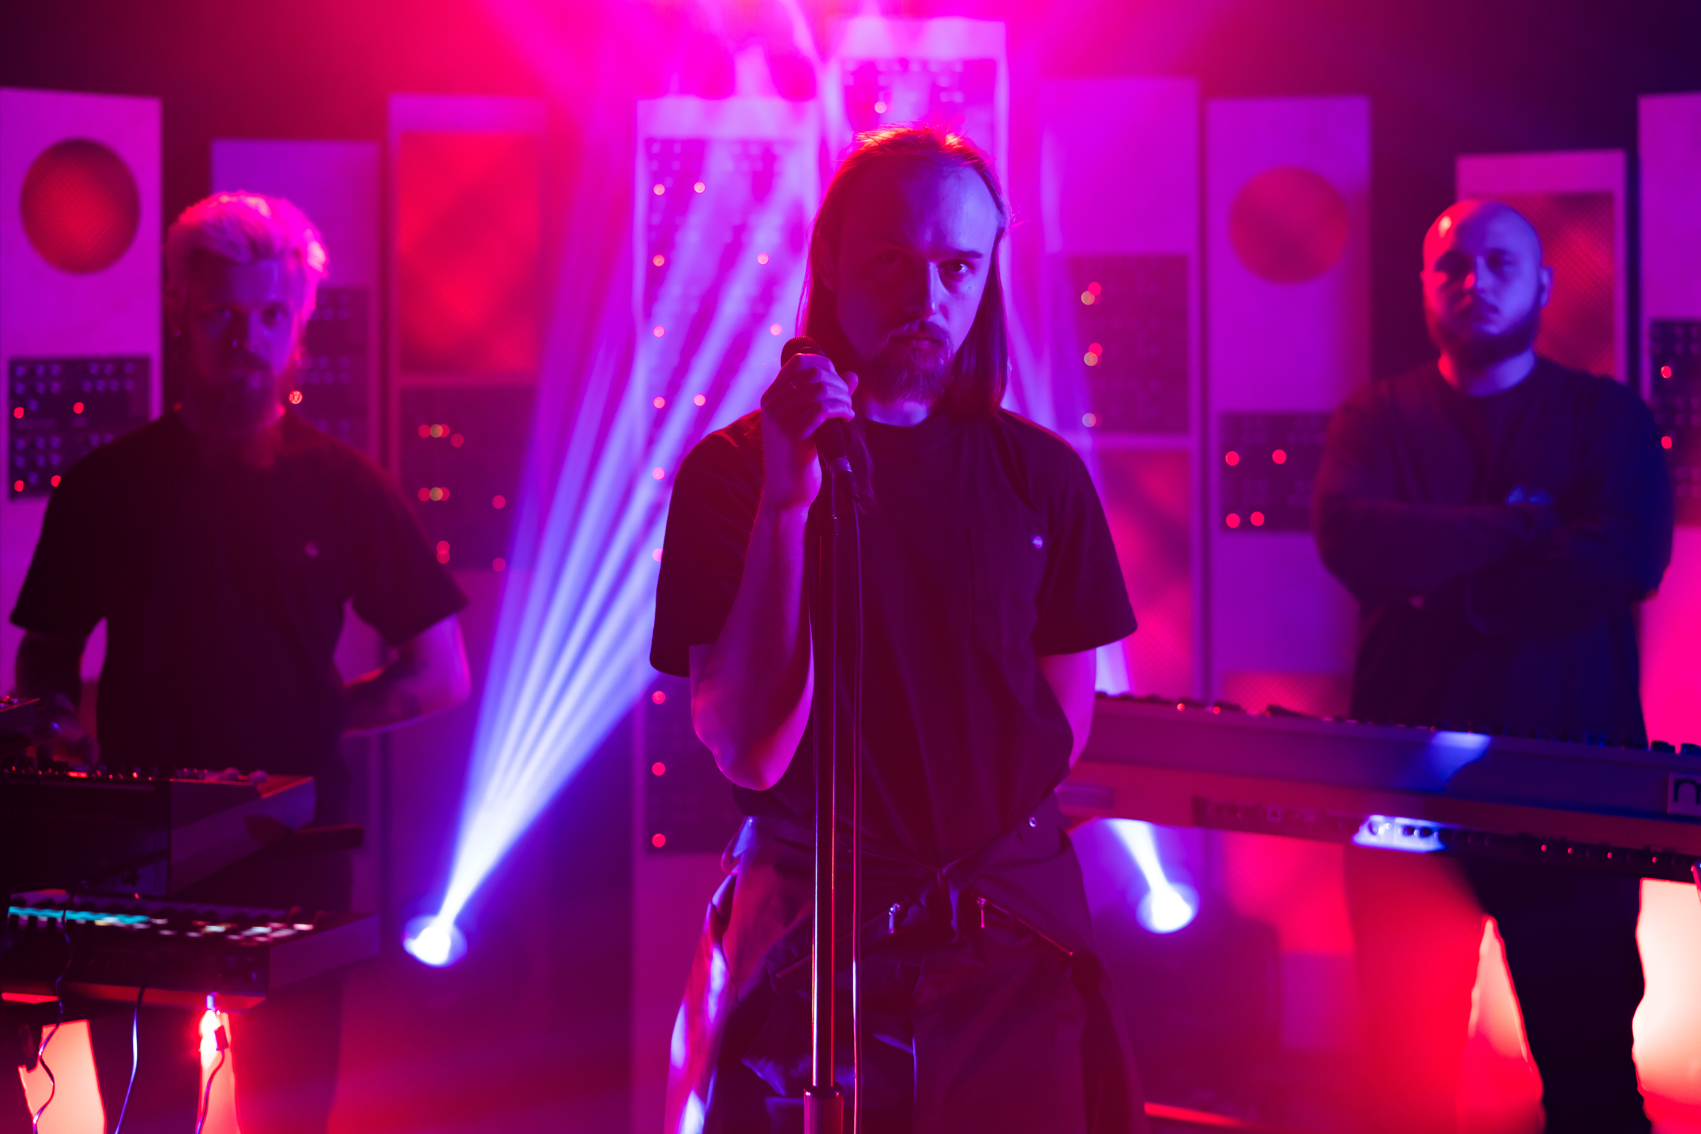  
[Download hi-res images here.](https://numark.sharepoint.com/:f:/s/Moog_Marketing/EqeLYgXQXFhKoY39w1epKVwBJr42LiFZTchuXOKYcRmTWw?e=FVB8bd)

In a recent visit to the Moog Sound Lab in Asheville, NC, Belarusian-turned-LA post-punk trio [Molchat Doma](http://molchatdoma.com) performed an exclusive version of “На дне (Na Dne),” the dark, danceable opening track of the band’s second studio album, *Этажи (Etazhi)*.

Formed in 2017 and currently on the coveted [Sacred Bones Records](https://www.sacredbonesrecords.com/) roster, Molchat Doma has been a force in defining today’s new-wave renaissance. The band’s synth-pop-meets-industrial style is a seamless and authentic representation of ‘80s synth-driven sound—revived and reimagined.

In [this performance](https://youtu.be/4Vv4cXz8PtY?si=iriw2q47-xMGwl8_) of “На дне (Na Dne),” the band blends warm synth leads, pulsing bass lines, and deep, droning vocals. On top of a simple, resolute drum machine beat, the artists use Moog One, Moog Grandmother, and a Novation 49SL MKIII to build the track’s melodic leads and bass.

[Watch the performance here.](https://youtu.be/4Vv4cXz8PtY?si=iriw2q47-xMGwl8_)

Molchat Doma is…

* Egor Shkutko: vocals
* Roman Komogortsev: guitar, synths, and drum machine
* Pavel Kozlov: bass and synths

For more about Molchat Doma, visit [molchatdoma.com](http://molchatdoma.com/).

To catch up on more Moog Sound Lab performances, check out [this playlist](https://www.youtube.com/playlist?list=PLfRv-D7DpUfE0kCWkPg91WI05McF13JEd). For more about Moog, visit [moogmusic.com](https://www.moogmusic.com).